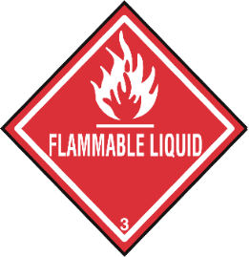 HAZARDOUS WASTE 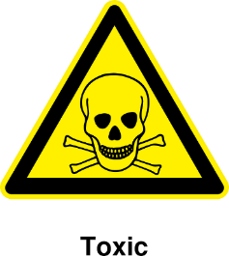
COLLECTION DAY
SATURDAY, AUG. 29, 2020
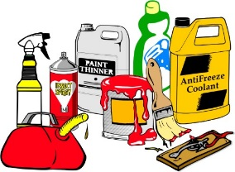 9:00 am – 12:00 pm 